**Experiment No : 05**

**Experiment Name :** Optical fiber Communication using DL2570 trainer(Analog Signal).

**Objective:**

Here you will study how analog signal generated by signal generator can be transmitted over fiber cable & reproduced at the receiver ends and monitoring by oscilloscope.

**Theory:**

Fiber optics can be used for transmission of digital as well as analog signal. Basically a fiber optics link contains three main elements, a transmitter, optical fiber and receiver. The transmitter modules take the input signal in electrical form and then transform it into optical energy containing the same information. The optical fiber is the medium, which takes the energy to the receiver. At the receiver light is converted back into receiver into electrical form at the same pattern as to originally fed to the transmitter.

**Apparatus:**

* Power supply.
* 20 MHz dual channel oscilloscope.
* 1 MHz Low Frequency Signal Generator.
* DL2570 De Lorenzo

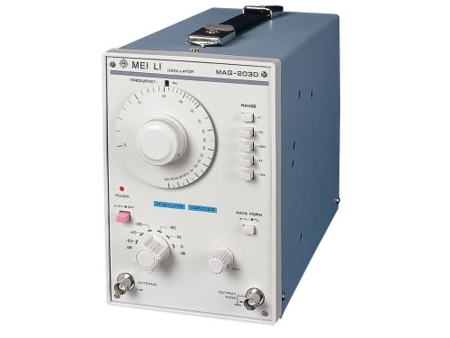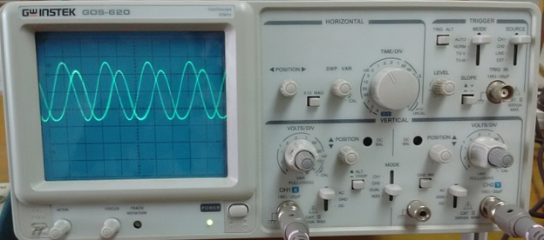

Oscilloscope Signal generator

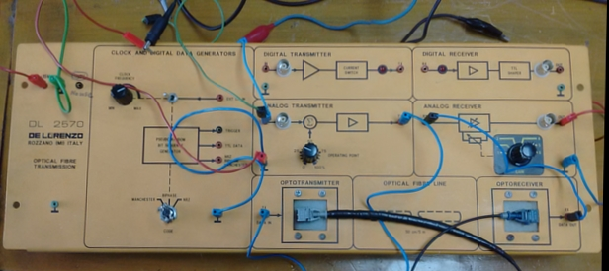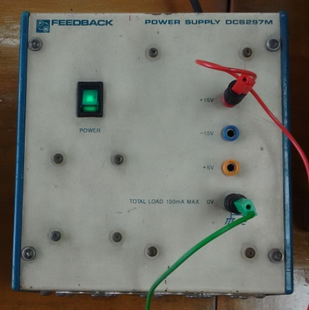

DL2570 trainer power supply

**Input and output Signal from oscilloscope:**

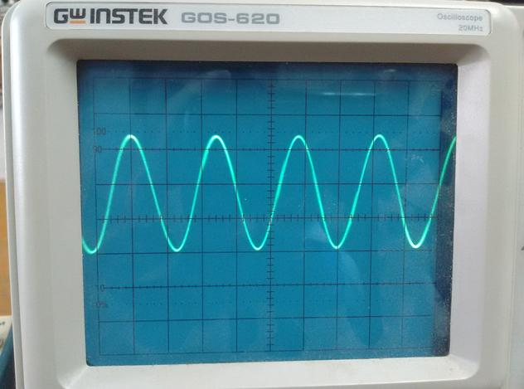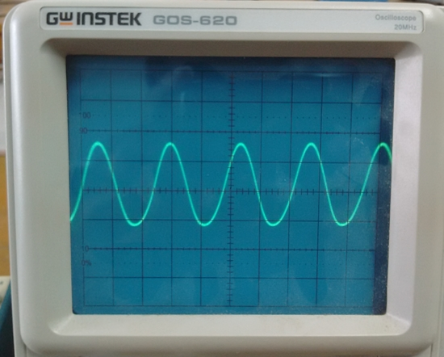

input output

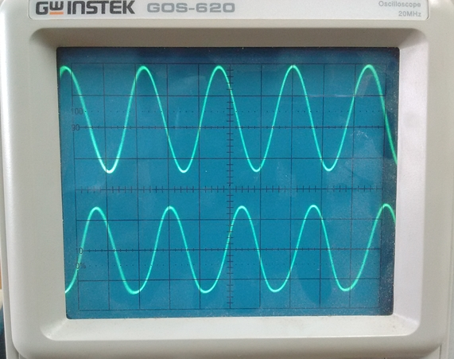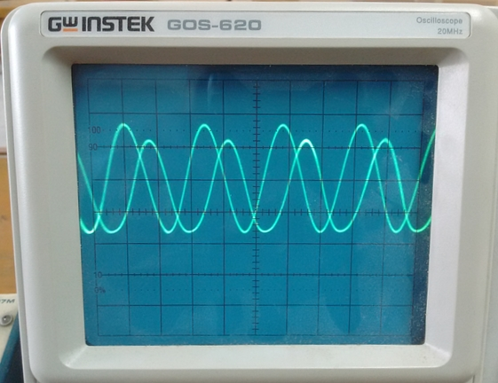

input and output

**Procedure and Observation :**

* Connect the power supply to the board.
* Make the optical fiber connections properly
* Switch on the power supply.
* Generate 1 MHz frequency analog signal by signal generator. Then connect Analog transmitter end and pass through optotransmitter and displaying signal in channel 1 of oscilloscope.
* Receive signal from the optoreceiver and pass through analog receiver to reproduce the input signal. Then displaying output signal in channel 2 of oscilloscope.
* Observe the input and output signal from oscilloscope and compare the original signal and output signal.
* Try a reflector removing the optical fiber and observe the output signal quality.